Coincident Points
# Source: AI Source: Provided by: [Data Path: Persons Table -> ID Column: 1, Name_En Column: Motasem Essam] -> From: [ChatGPT] on [7/25/2026]
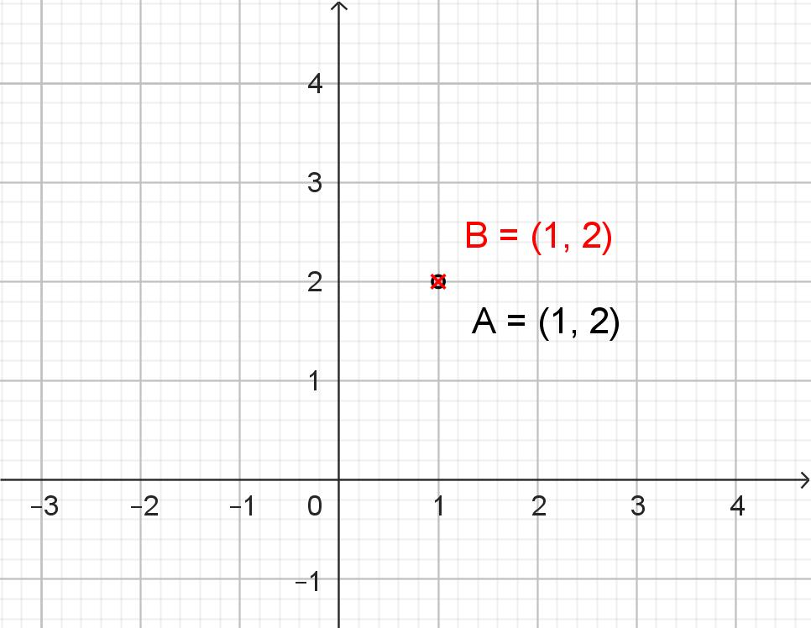
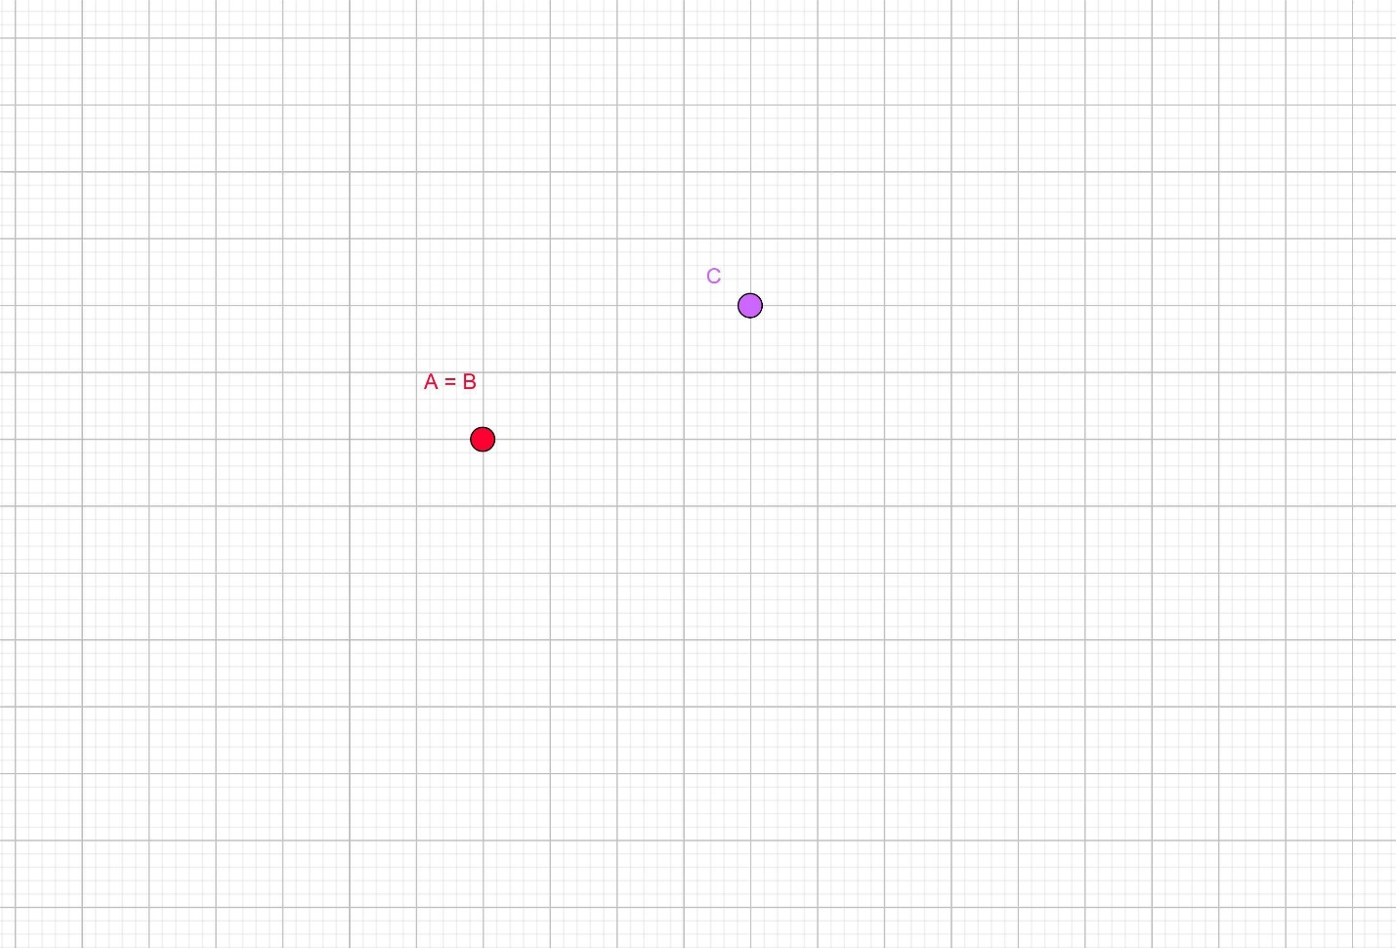

Definition
# Source: AI Source: Provided by: [Data Path: Persons Table -> ID Column: 1, Name_En Column: Motasem Essam] -> From: [ChatGPT] on [7/25/2026]
Coincident Points are two or more points that occupy exactly the same location in space. Although they may be given different names in a geometric construction or mathematical description, they represent the same geometric position.
In other words, coincident points have identical coordinates and are considered to overlap completely.

Characteristics
# Source: AI Source: Provided by: [Data Path: Persons Table -> ID Column: 1, Name_En Column: Motasem Essam] -> From: [ChatGPT] on [7/25/2026]
Coincident points:
- Occupy the same exact location.
- Have identical coordinates.
- Appear as a single point in a diagram.
- May have different labels but represent one position.
- Have zero distance between them.

Illustration
# Source: AI Source: Provided by: [Data Path: Persons Table -> ID Column: 1, Name_En Column: Motasem Essam] -> From: [ChatGPT] on [7/25/2026]
• A, B
Points A and B are located at exactly the same position, so they are coincident points.

Coordinate Representation
# Source: AI Source: Provided by: [Data Path: Persons Table -> ID Column: 1, Name_En Column: Motasem Essam] -> From: [ChatGPT] on [7/25/2026]
If two points have the same coordinates:
$$A\left(x , y\right) \\ B\left(x , y\right)$$
then
$$A≡B$$
Example:
$$A\left(4 , 2\right) \\ B\left(4 , 2\right)$$
Since both points have identical coordinates, they are coincident.

Distance Between Coincident Points
# Source: AI Source: Provided by: [Data Path: Persons Table -> ID Column: 1, Name_En Column: Motasem Essam] -> From: [ChatGPT] on [7/25/2026]
The distance between two coincident points is:
$$d=0$$
because they occupy the same location.

Examples
# Source: AI Source: Provided by: [Data Path: Persons Table -> ID Column: 1, Name_En Column: Motasem Essam] -> From: [ChatGPT] on [7/25/2026]
Coincident points may occur:
- At the intersection of geometric constructions.
- When two endpoints overlap.
- In coordinate geometry when two points share identical coordinates.
- In computer graphics when multiple objects reference the same vertex.
- In CAD models where vertices are merged.

Properties
# Source: AI Source: Provided by: [Data Path: Persons Table -> ID Column: 1, Name_En Column: Motasem Essam] -> From: [ChatGPT] on [7/25/2026]
Coincident points:
- Represent one geometric position.
- Have zero separation distance.
- Cannot be visually distinguished unless labels are shown.
- May be treated as a single point in geometric analysis.

Applications
# Source: AI Source: Provided by: [Data Path: Persons Table -> ID Column: 1, Name_En Column: Motasem Essam] -> From: [ChatGPT] on [7/25/2026]
Coincident points are used in:
- Geometry
- Coordinate Geometry
- CAD (Computer-Aided Design)
- Computer Graphics
- Engineering Drawings
- Robotics
- GIS (Geographic Information Systems)
- Mesh Modeling
- Finite Element Analysis (FEA)

Advantages
# Source: AI Source: Provided by: [Data Path: Persons Table -> ID Column: 1, Name_En Column: Motasem Essam] -> From: [ChatGPT] on [7/25/2026]
Studying coincident points helps to:
- Identify overlapping geometric elements.
- Simplify geometric constructions.
- Improve CAD and mesh models.
- Detect duplicate coordinates.
- Support computational geometry algorithms.

Limitations
# Source: AI Source: Provided by: [Data Path: Persons Table -> ID Column: 1, Name_En Column: Motasem Essam] -> From: [ChatGPT] on [7/25/2026]
Coincident points:
- Cannot be visually distinguished without labels.
- May introduce ambiguity if unintentionally duplicated in geometric models.
- Often require computational checks in digital systems.

Comparison with Other Types of Points
# Source: AI Source: Provided by: [Data Path: Persons Table -> ID Column: 1, Name_En Column: Motasem Essam] -> From: [ChatGPT] on [7/25/2026]
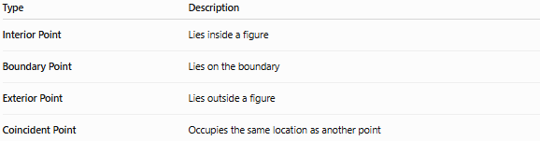
Type | Description
Interior Point | Lies inside a figure
Boundary Point | Lies on the boundary
Exterior Point | Lies outside a figure
Coincident Point | Occupies the same location as another point

Key Points
# Source: AI Source: Provided by: [Data Path: Persons Table -> ID Column: 1, Name_En Column: Motasem Essam] -> From: [ChatGPT] on [7/25/2026]
- Coincident Points occupy exactly the same location.
- They have identical coordinates.
- The distance between coincident points is zero.
- Multiple labels may refer to the same physical point.
- Coincident points are important in geometry, CAD, computer graphics, engineering, and computational geometry.

Conclusion
# Source: AI Source: Provided by: [Data Path: Persons Table -> ID Column: 1, Name_En Column: Motasem Essam] -> From: [ChatGPT] on [7/25/2026]
Coincident Points are points that share the exact same position in space, making them geometrically indistinguishable except by their labels. They have identical coordinates and a distance of zero between them, often representing a single location referenced in different ways. Coincident points are fundamental in geometry, coordinate geometry, engineering, CAD, computer graphics, robotics, GIS, and computational modeling, where recognizing overlapping points is essential for accurate design, analysis, and visualization.

